
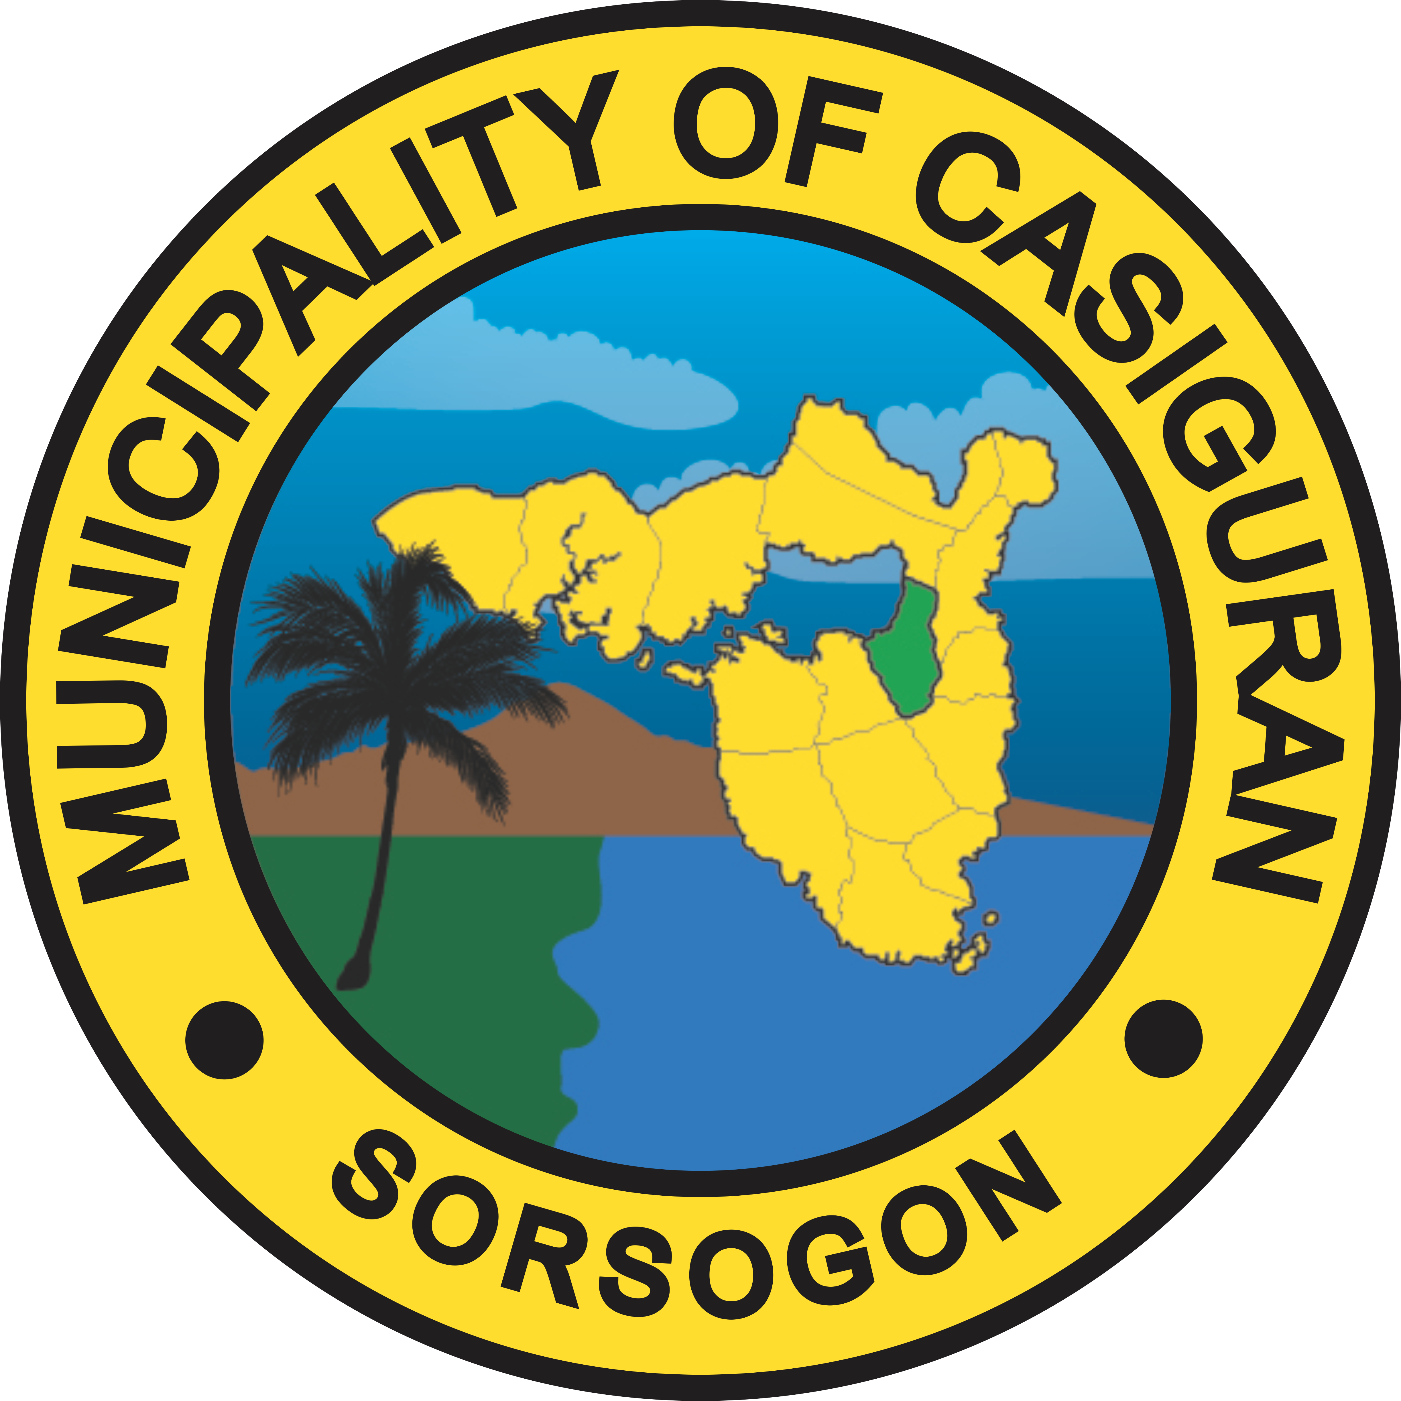
Republic of the Philippines
Province of Sorsogon
MUNICIPALITY OF CASIGURAN

Notice of Award

______________

{{proprietor_upper}}
Proprietor //Owner
{{company_name_upper}}
{{address}}

Dear Ma’am/Sir;

We are happy to notify you that the {{project_title}} is hereby awarded you as the Bidder with the Lowest Calculated Responsive Bid at a Contract Price equivalent to {{contract_amount_in_words}} only ({{bid_formatAmount}}).

You are therefore required, within ten (10) days from the receipt of this Notice of Award, to formally enter into contract with us, and to submit the Performance Security in the form and the amount stipulated in the Instructions to Bidders. Failure to enter into the said contract or provide the Performance Security shall constitute a sufficient ground for cancellation of this award and forfeiture of your Bid Security.

Very truly yours,

MARIA MINEZ R. HAMOR
Municipal Mayor

Conformed:

{{proprietor_upper}}
{{company_name_upper}}

Date: {{notice_date}} .

